**Setting Up Application Environment**

|  |  |
| --- | --- |
| **Date** | 31October 2022 |
| **Team ID** | PNT2022TMID43345 |
| **Project Name** | Project – Inventory Management System for Retailers |

**Flask Project:**

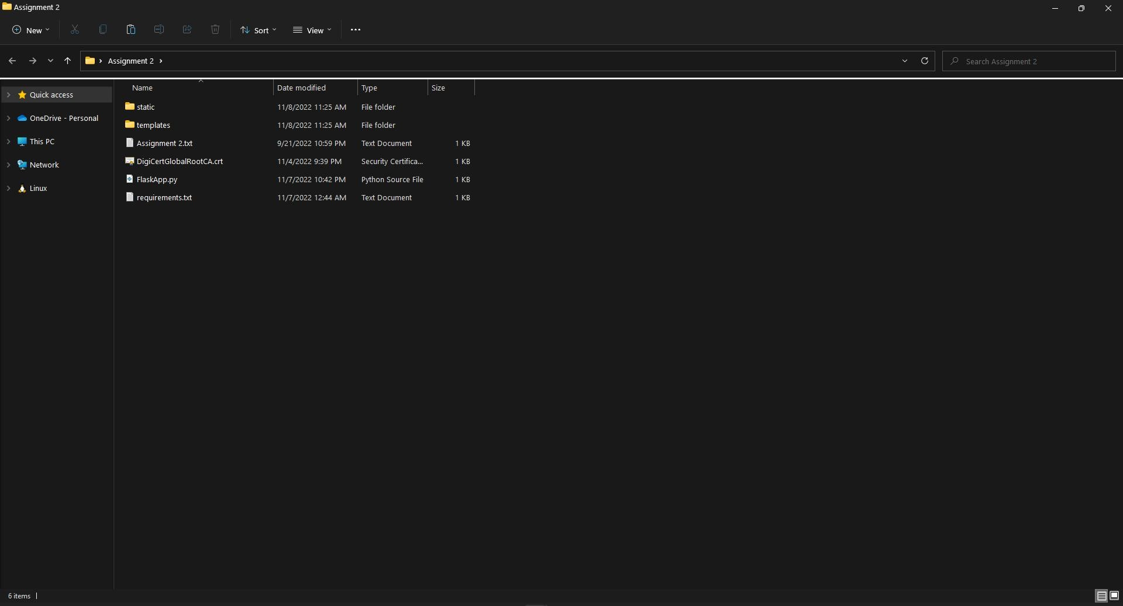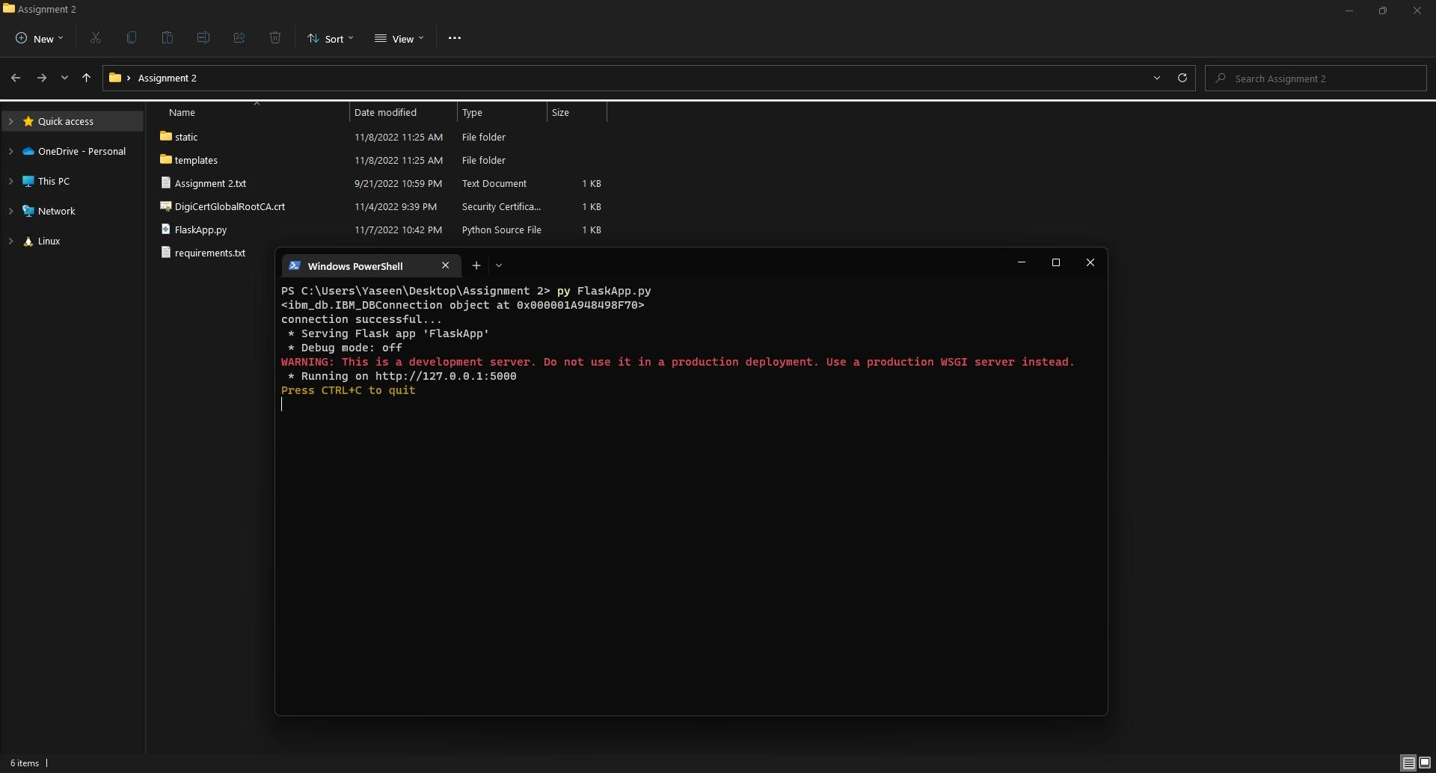

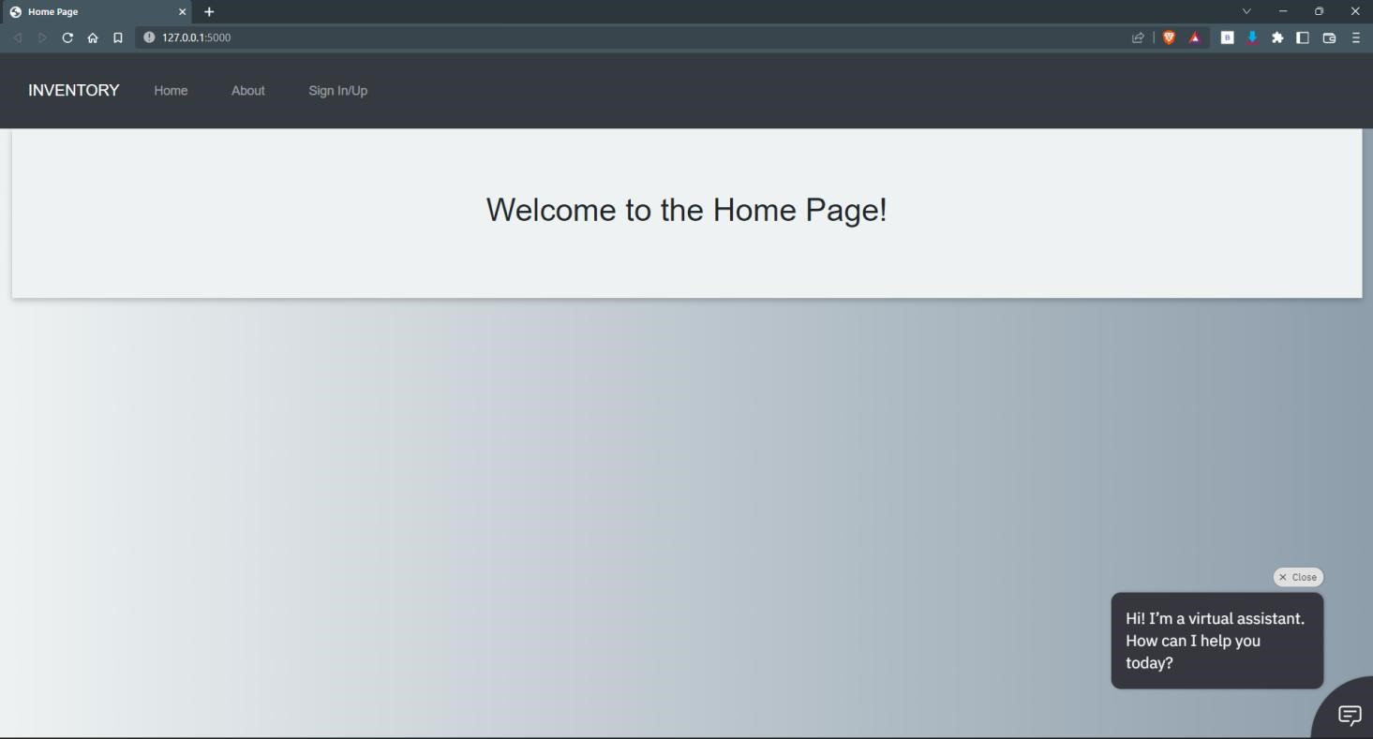

**Create IBM Cloud Account:**

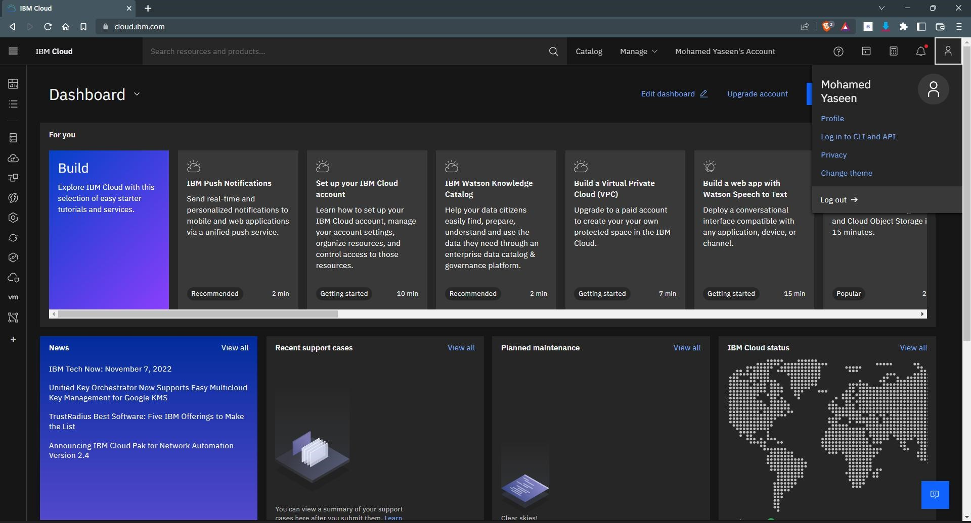

**Install IBM Cloud CLI:**

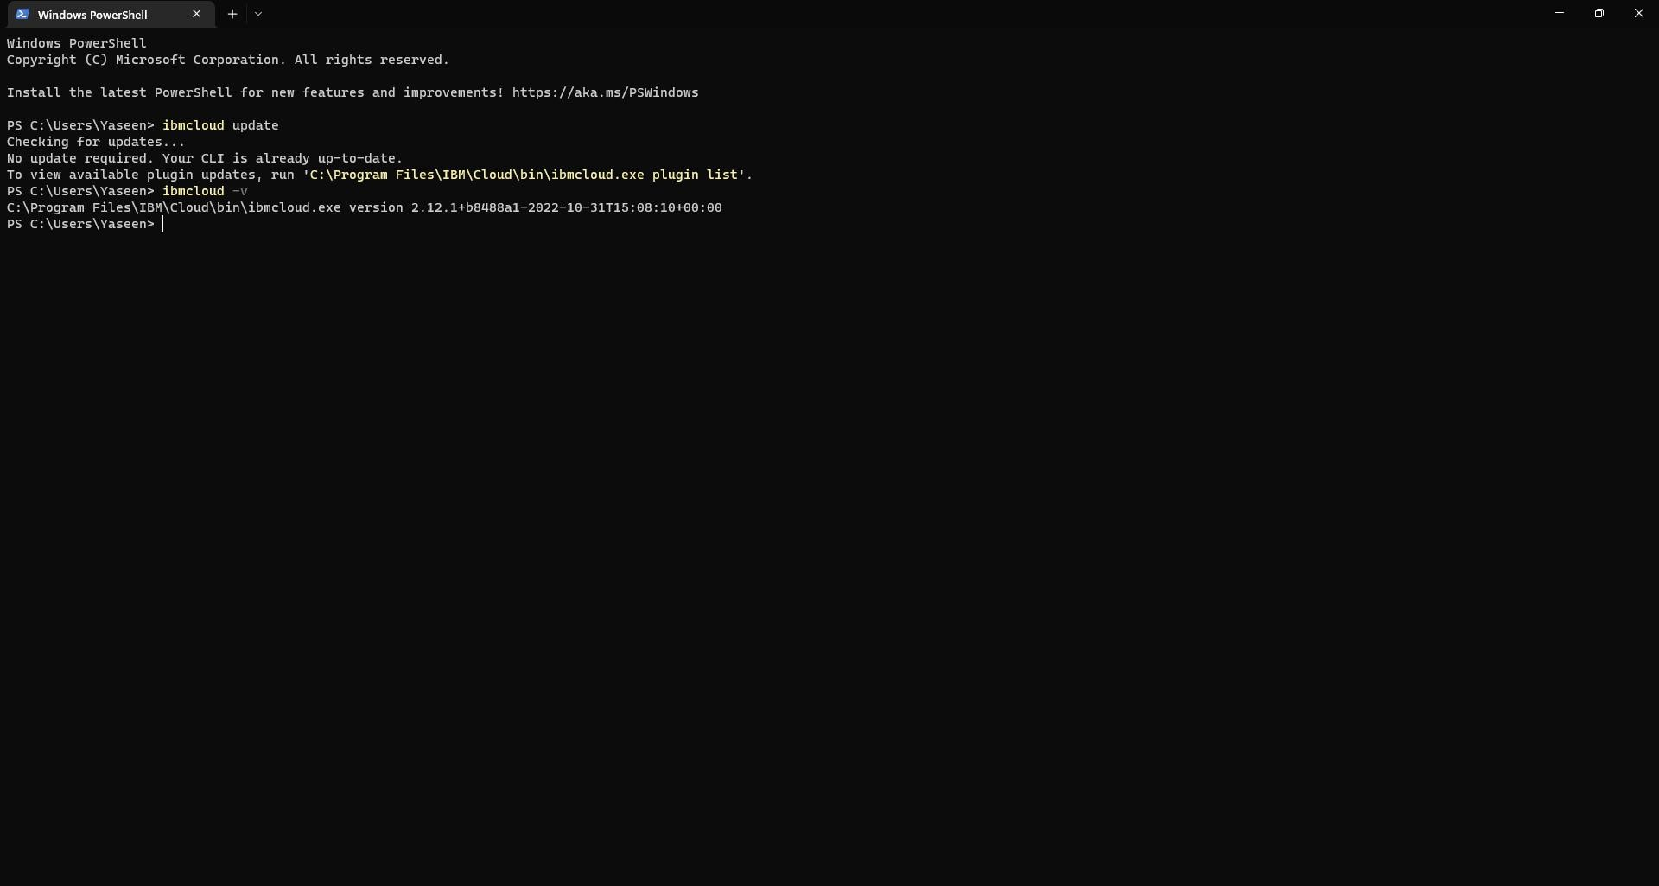

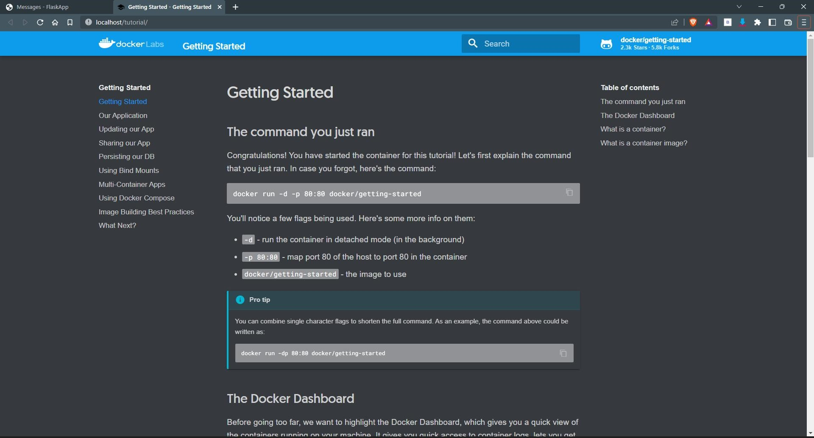**Docker Setup:**

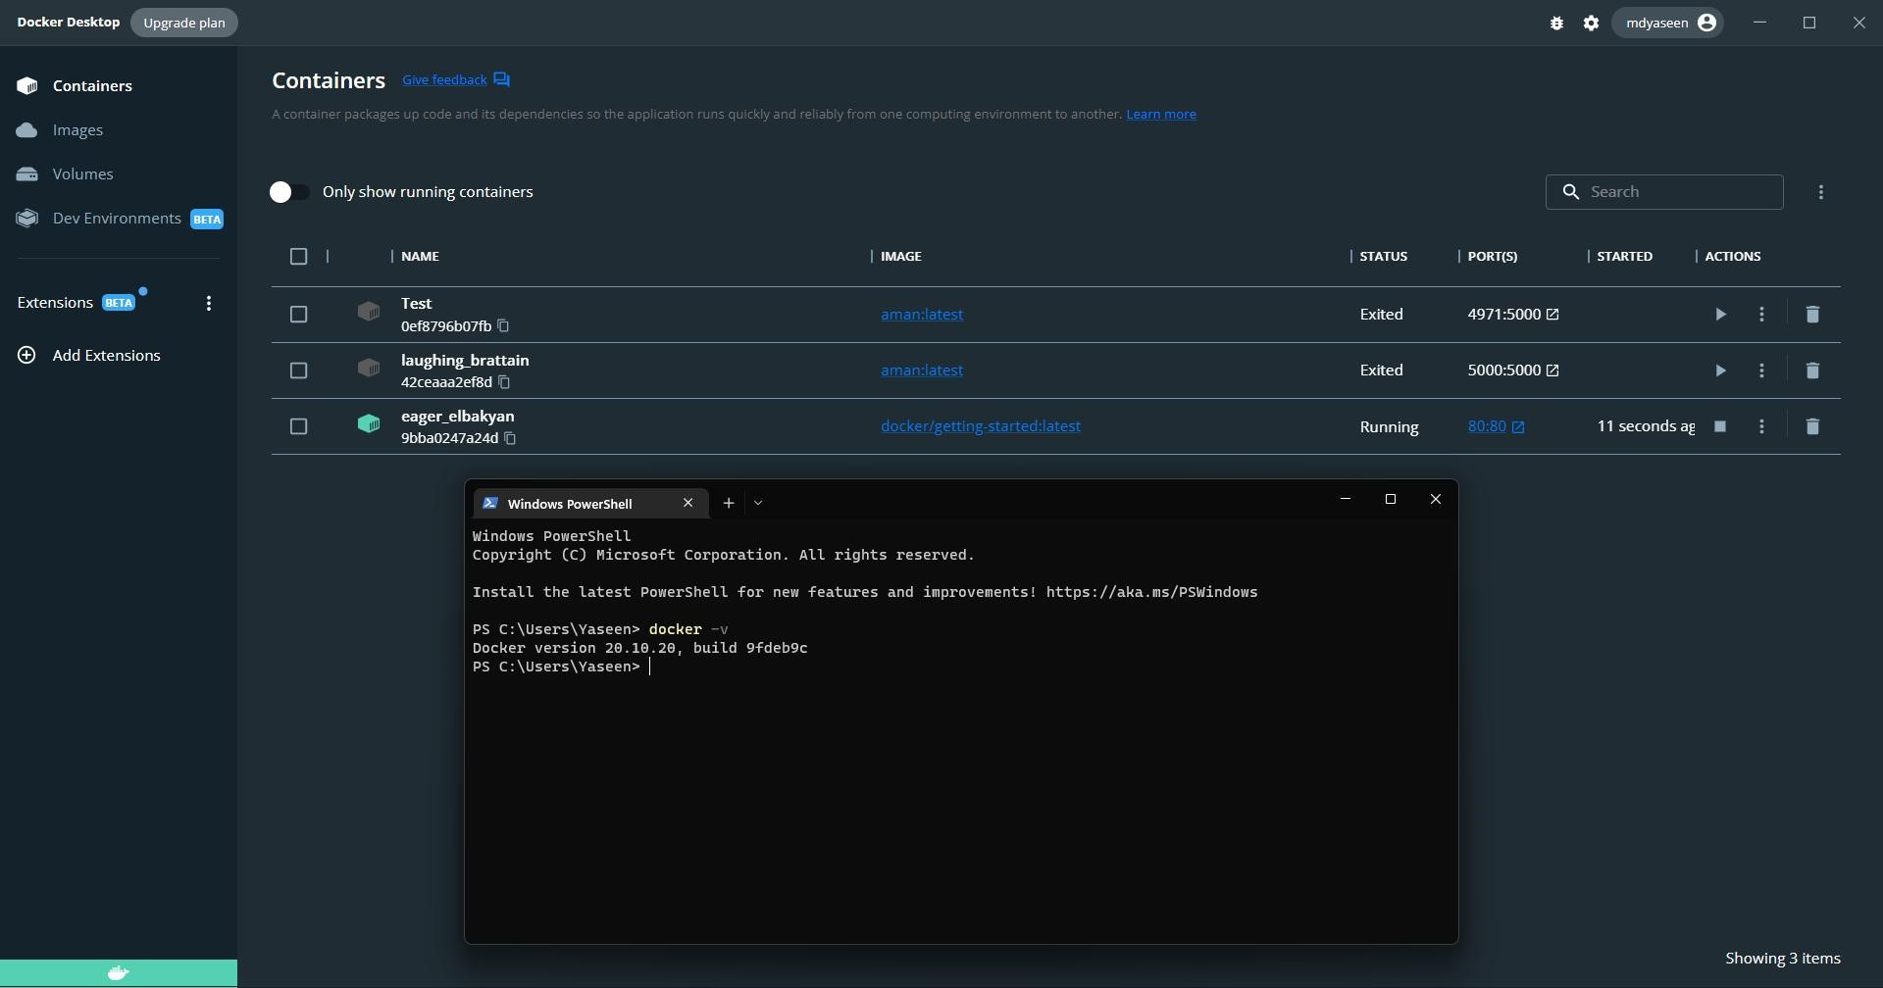

**Create an account in SendGrid:**

